**Gracious Germents**

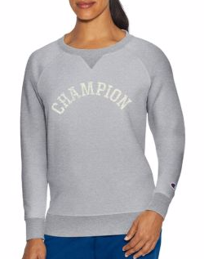

**DESCRIPTION:**

Our iconic Sweatshirt with Champion heritage graphics and better-than-ever feel.

Cotton-rich blend is garment washed for superior softness and vintage look.

Brushed interior is super-soft against skin.

Stretch ribbed side insets, cuffs and waistband for a stay true fit.

Raglan sleeves let you move with ease.

Wider neckline with vintage V-coverstitch detail.

Retro Champion arch graphic, C logo on cuff.

Units Per Pack: 1

Fabric Content: 72% Cotton/28% Polyester; 1X1 Rib Trim

Country of Origin: Imported

**ADDITIONAL INFORMATION**

Weight: 0.5 kg

Dimensions: 10 × 8 × 3 cm

Size: S, M, L, XL,

Price: $20.00